Урок по теме:
«Биография».
“Biography”
Тип урока – комбинированный
Цели и задачи урока: обобщить изученный материал по теме «Биография», повторить и закрепить изученную лексику и грамматику (порядковые числительные), практиковать навыки аудирования, чтения и говорения.
- Практические задачи:
- 1. Активизировать употребление лексики по теме «Биография» в речи уч-ся. 2.Практиковать уч-ся в аудировании.
- 3. Учить читать с общим охватом содержания, осуществляя поиск информации в тексте. 4. Учить вести диалог-расспрос.
- Воспитательные задачи:
1. Развивать навыки участия в групповом общении.
- Расширять общий кругозор уч-ся.
- Развивающие задачи:
- 1. Развивать внимание, наблюдательность, умение слушать, речевую инициативу 2. Развивать ценностные ориентации, мышление, память, чувства и эмоции.
- План урока:
1) Организационный момент: Рапорт дежурного.
- Good morning, dear boys and girls!
-Good morning, dear teacher!
- - I am glad to see you again! Today we have unusual lesson, as you can see we have a lot of guests. I would like to talk about with you first of all. Do you like it? What is the weather like today? What is your favourite weather? Ok ,let`s go on
1.Phonetic drills: . Вводное слово учителя.
T: Today we continue to speak about your family and about the biography of famous people and we‘ll learn how to interview the people to know more about them. But first of all let’s begin with the phonetic.
III. Фонетическая зарядка.
T: Pay attention to the pronunciation of the following sounds and words: 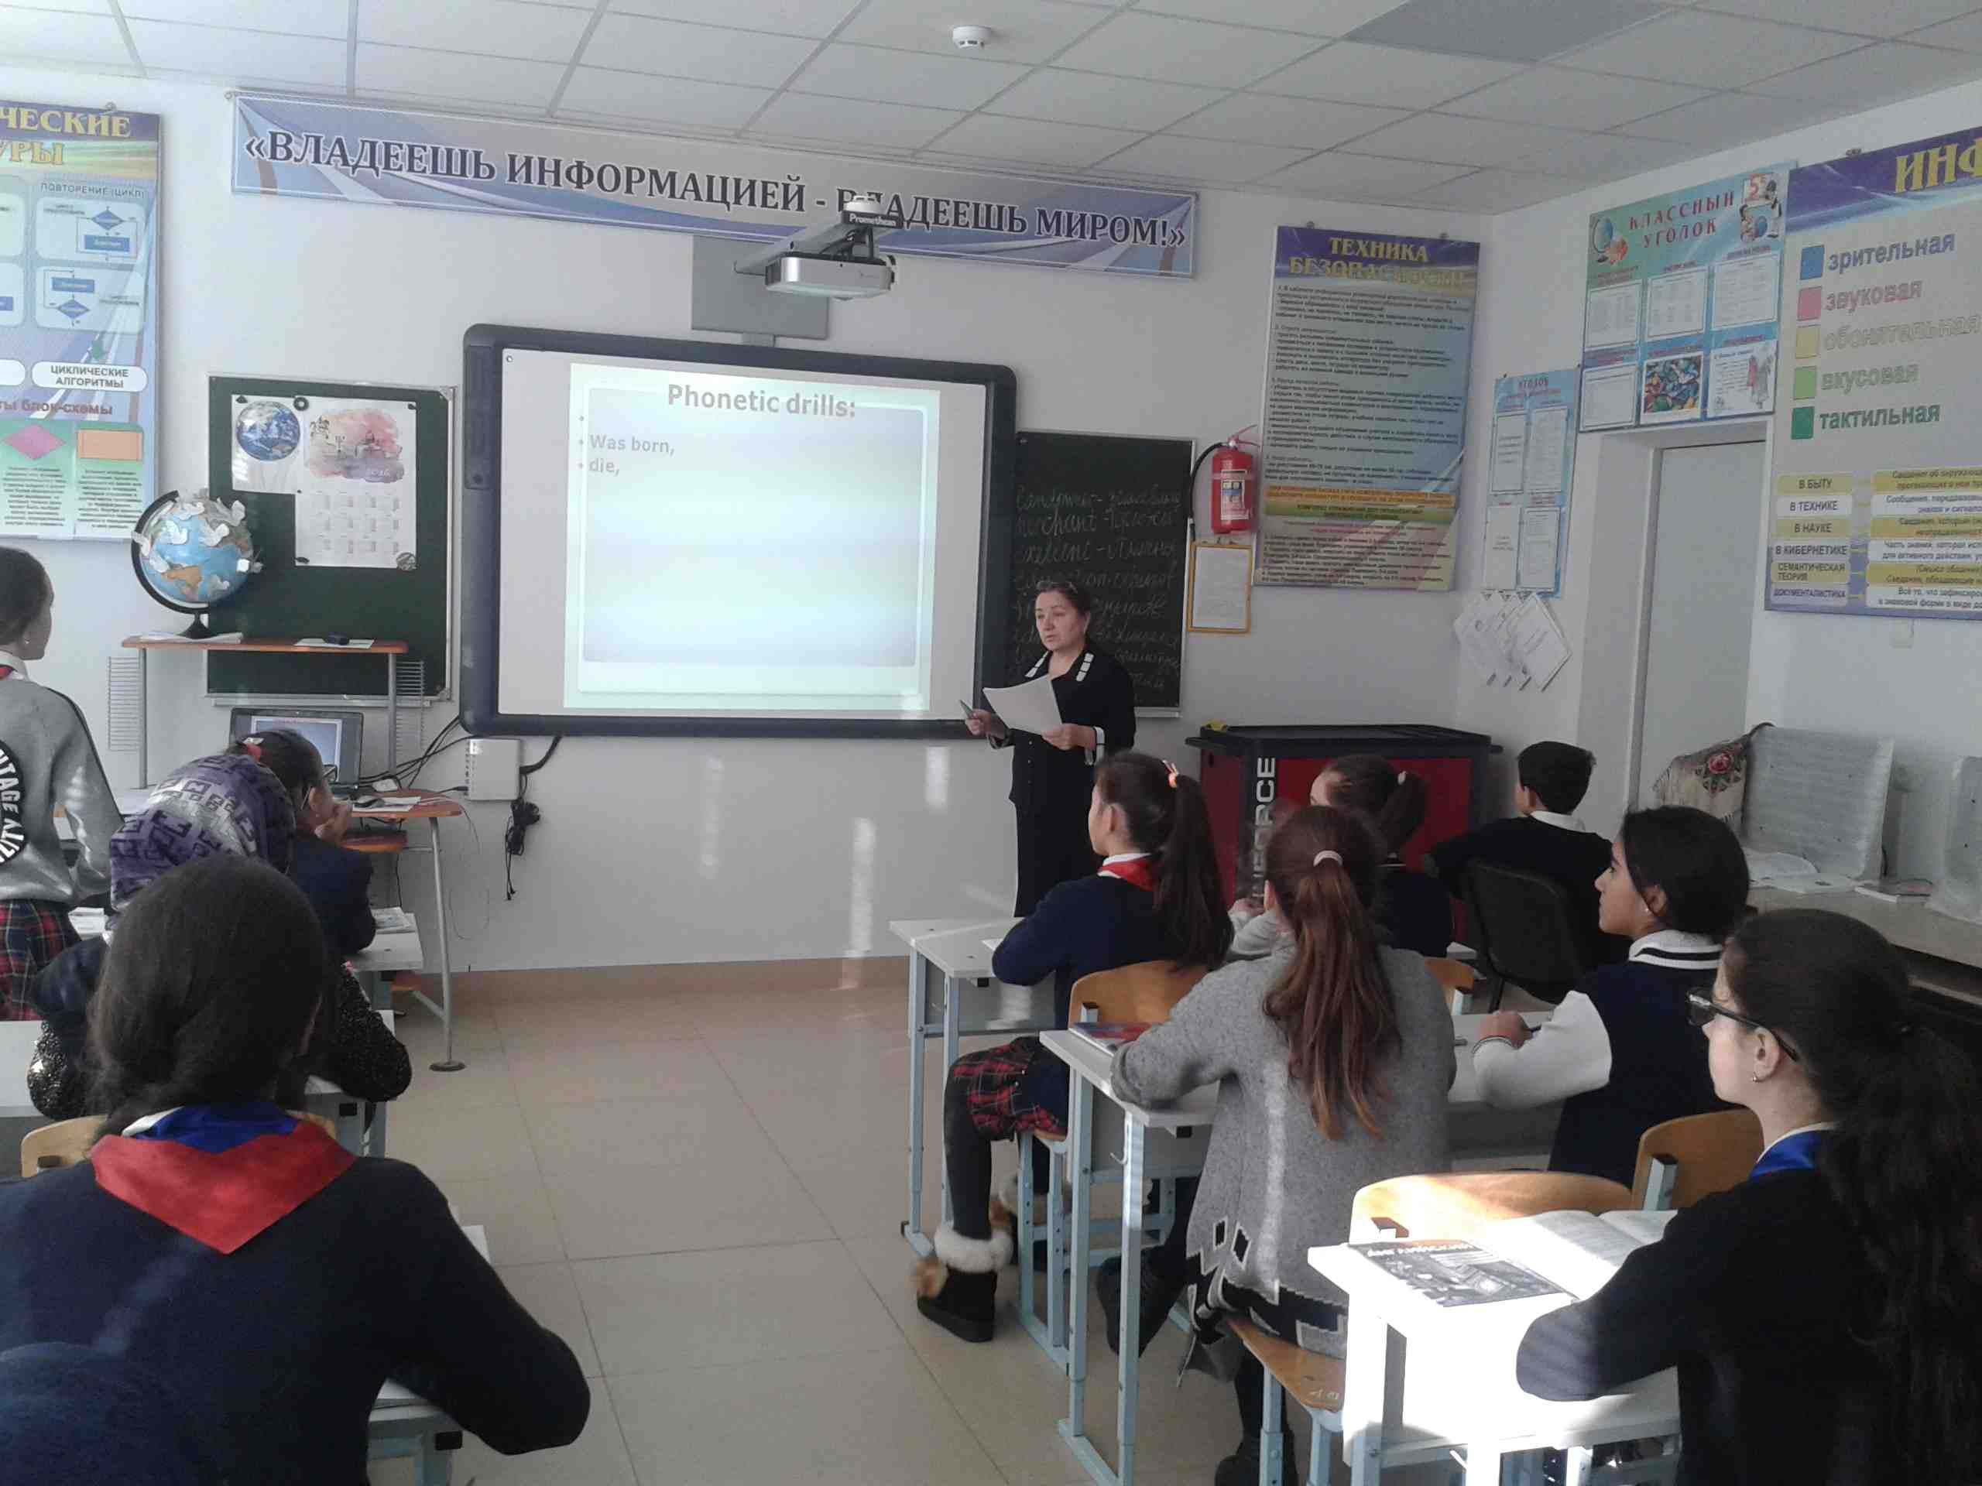

- Was born, die,
- to choose a career, to be a success,
- a small animals, a successful student,
- to become a writer, look after,
- to marry a doctor, a terrible job,
- Wonderful dreams a difficult text,
- leave the house ask,
- a medical college a clever answer,
- an unusual question, interest.

2.Match them
- A)to ask 1.for music
- B)to leave 2.a beautiful woman
- C)to answer 3.guestions
- D)to marry 4.teacher
- E)to be interested 5.in animals
- G)to have 6.the house
- H)a successful 7.a lot of money
- K)a talent 8.the telephone
3.Образуйте степени сравнения прилагательных со следующими словами и переведите их: 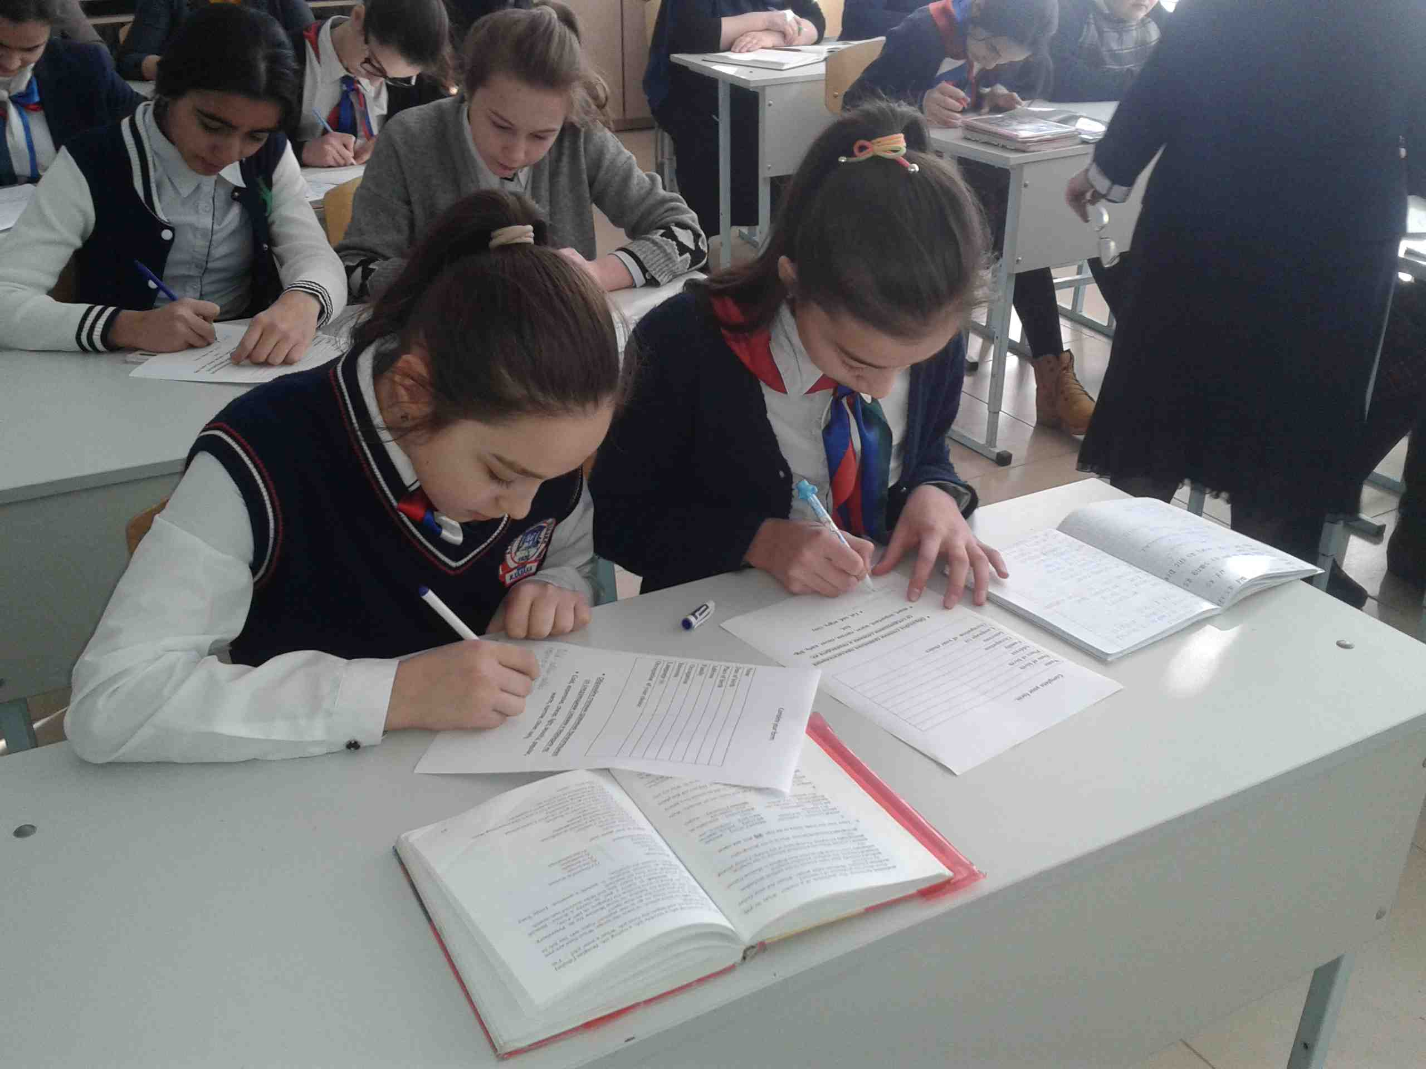
- Cold, cheap, short, warm, good, cosy, angry, clever, narrow, Fat, happy, bad, early, sad,
- hot, big. interesting, short, angry, important, popular, beautiful
- For –example: Cold-colder- the coldest Good –better-the best Fat –fatter-the fattest Interesting- more interesting-the most interesting
4.Can you write the numbers in words ? 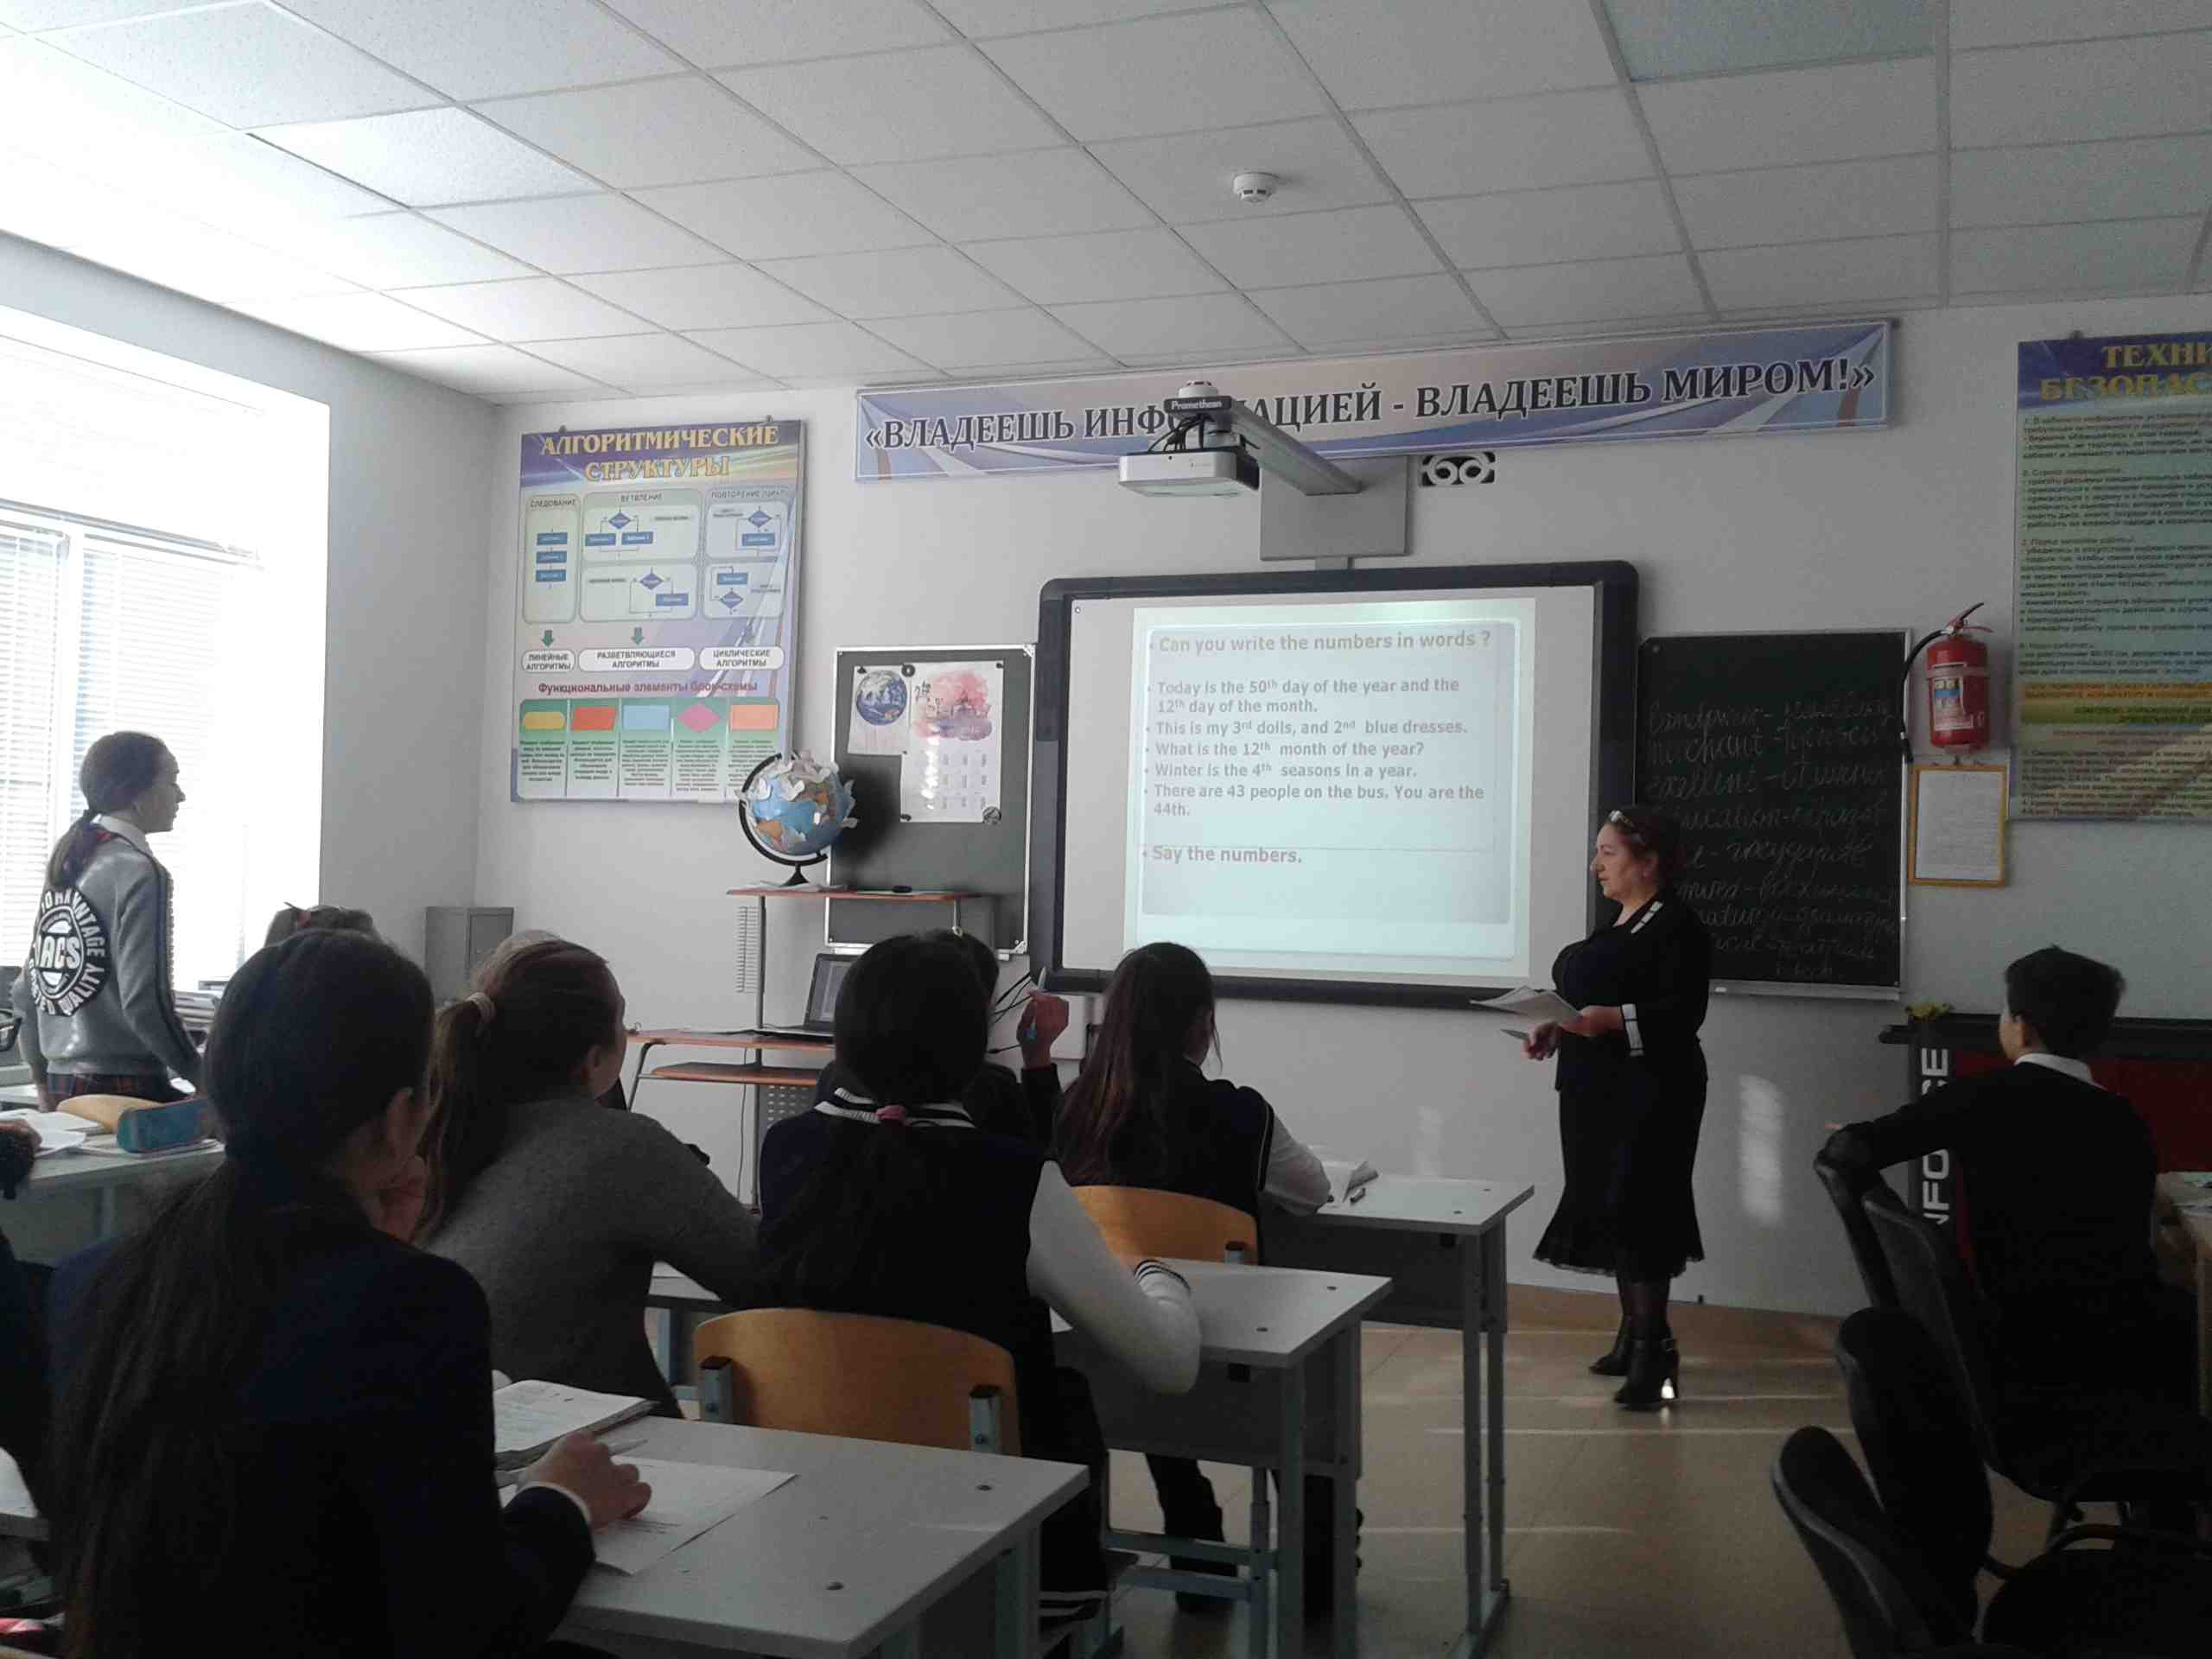
- Today is the 50th day of the year and the 12th day of the month.
- This is my 3rd dolls, and 2nd blue dresses.
- What is the 12th month of the year?
- Winter is the 4th seasons in a year. There are 43 people on the bus. You are the 44th.
- Say the numbers.
1,5,67,98,54,100,84. 21st,22nd,33nd ,44th ,55th 66th,77th,88th,99th
5. Can you write the numbers in words ?
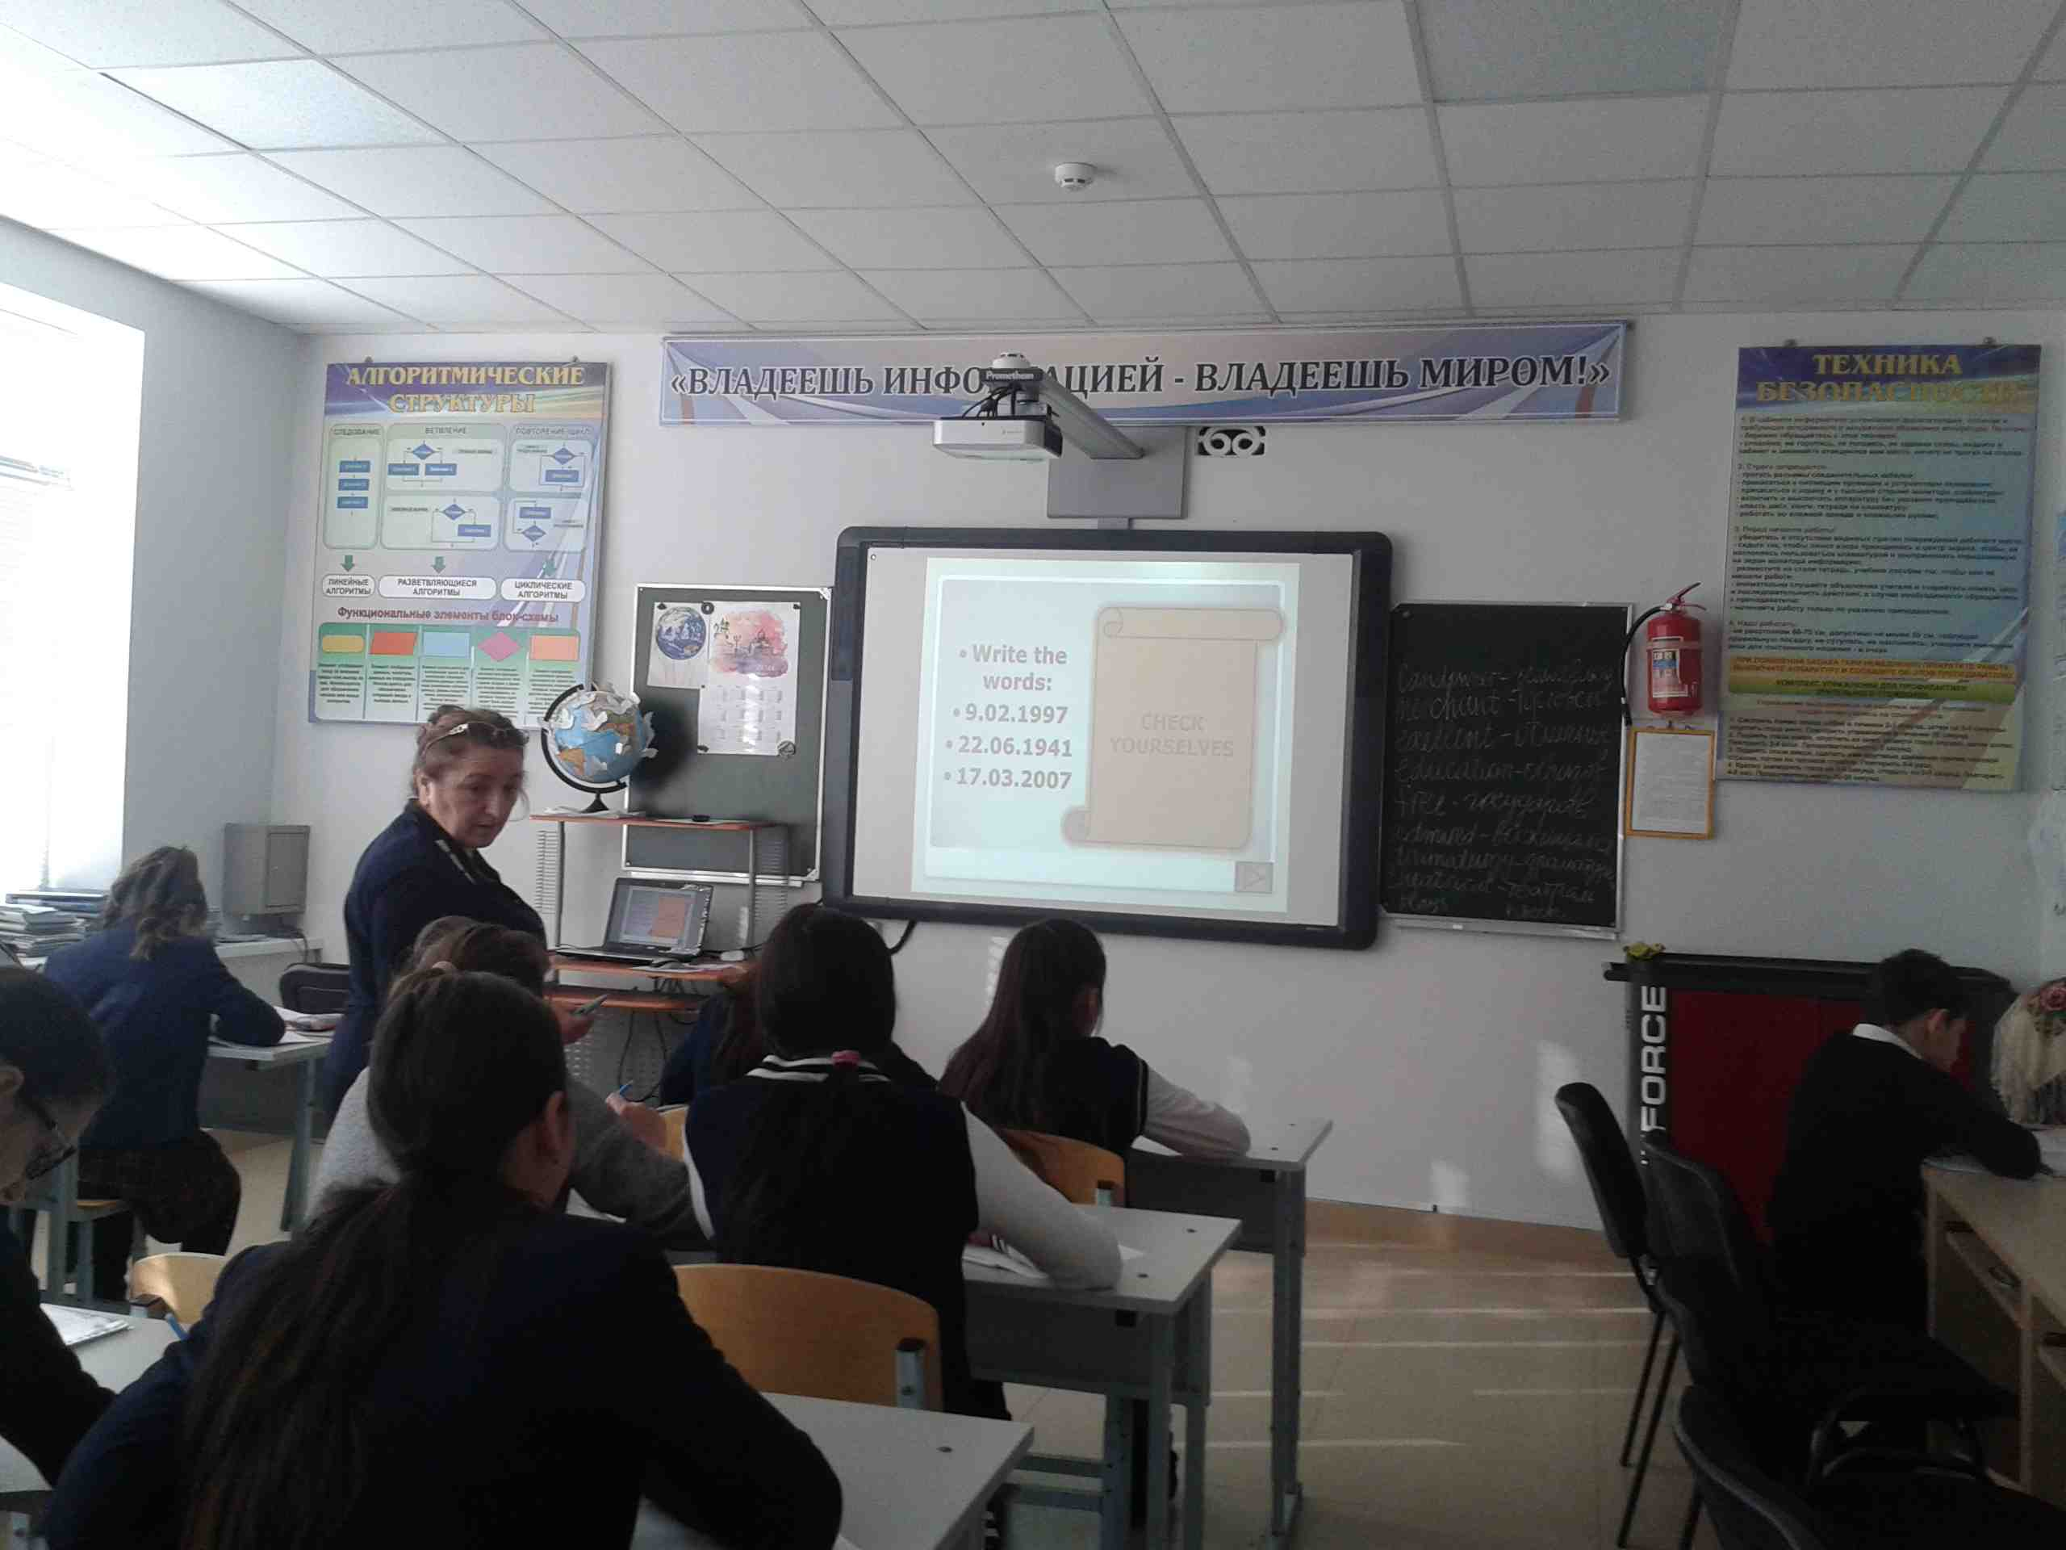
- 9.02.1997 The ninth of February nineteen ninety seven
- 22.06.1941
- 17.03.2007
- 6.Напиши недостающие слова
- one | - many | - one | - many
- man | - men | - fish | - fish
- city | - cities | - shelf | - shelves
- child | - children | - mouse | - mice
- horse | - horses | - women | - women
- tooth | - teeth | - goose | - geese
- sheep | - sheep | - deer | - deer
- box | - boxes | - bench | - benches
- 7.Complete your form. 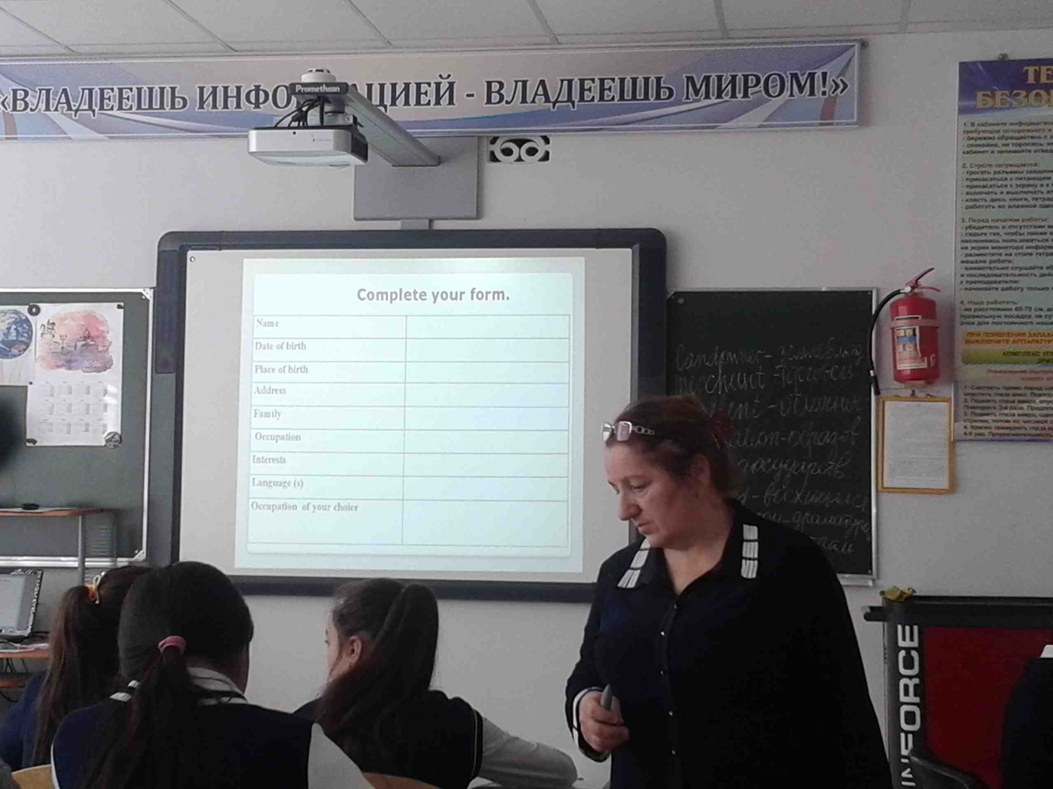
- Name
- Date of birth
- Place of birth
- Address
- Family
- Occupation
- Interests
- Language (s)
- Occupation of your choice
8. Развитие навыков диалогической речи:
(Работа в парах) Ролевая игра «Мы берем интервью».
T: And now let’s play a game. One of you will be the famous journalist. And the others will be asked your questions the journalists. Your task is to interview this person to know some facts of your life.
Answer the journalists questions.
Act the dialogue out.

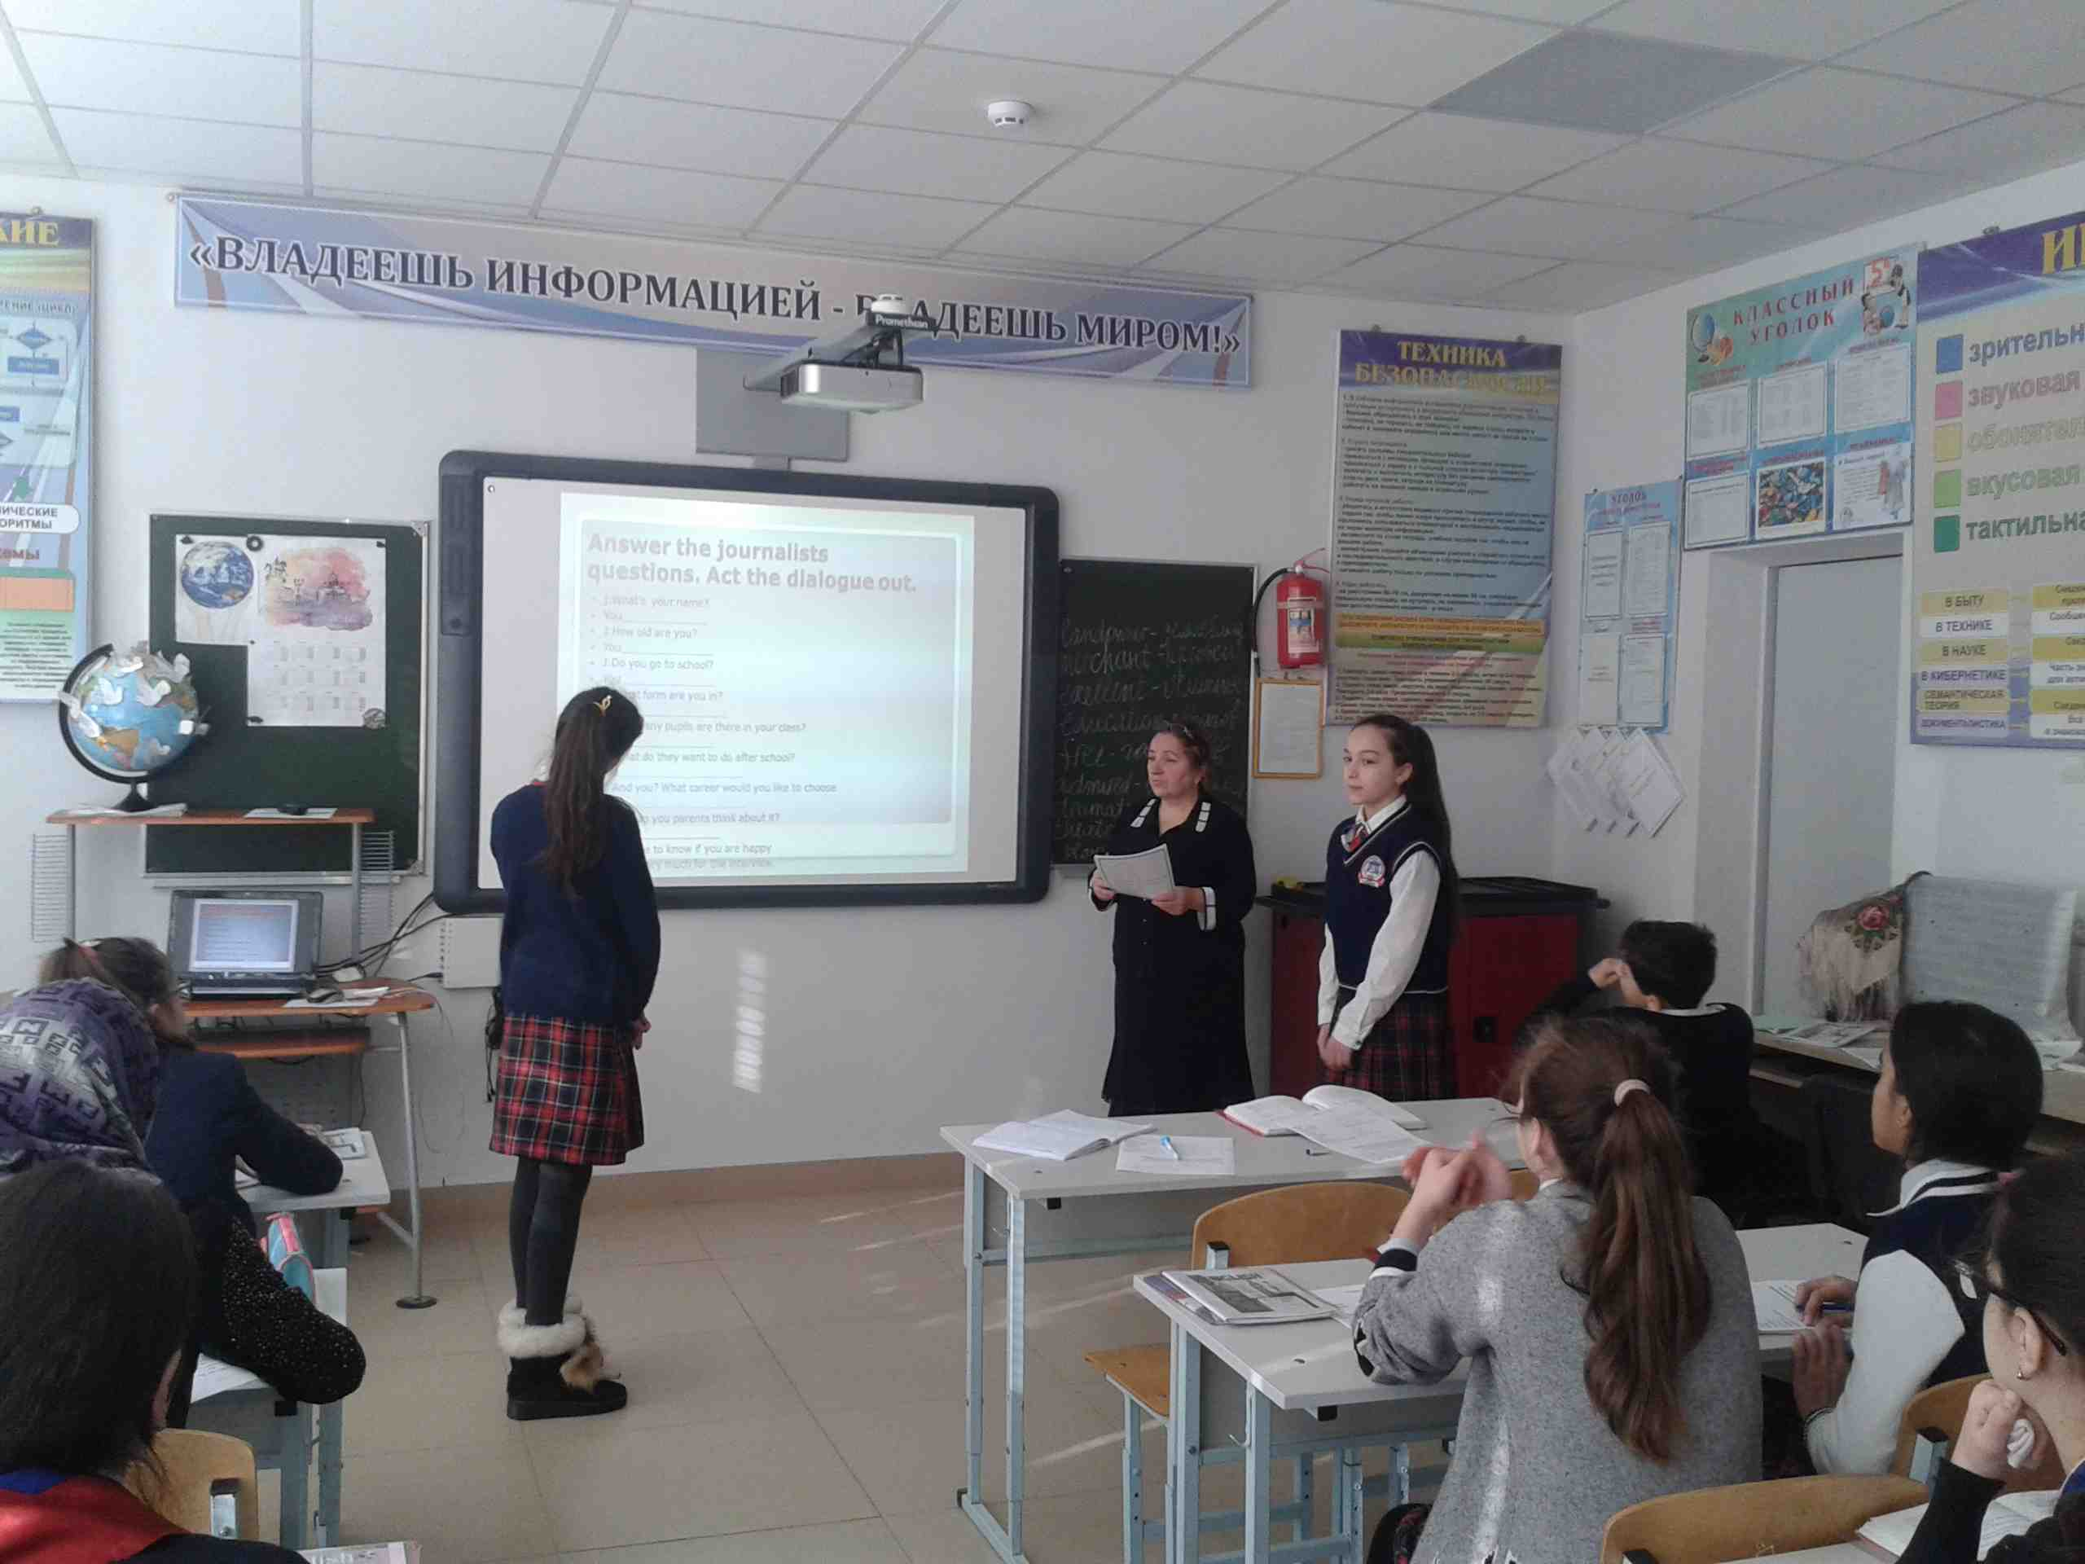
- j:What's your name? You_________ J:How old are you? You_______________ J:Do you go to school? You ______________ J: What form are you in? You _________________ J:How many pupils are there in your class? You _______________ J: What do they want to do after school? You ____________________ J: And you? What career would you like to choose You__________ j: What do you parents think about it? You_______ j:I would like to know if you are happy.
- Thank you very much for the interview.
- 9.Read the text and answer the questions: 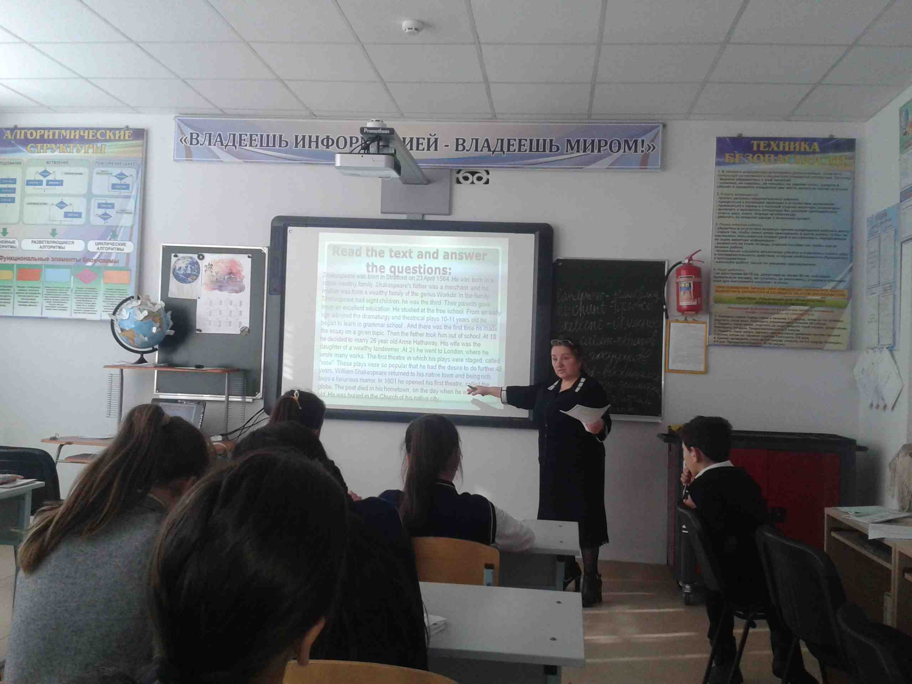
- Shakespeare was born in Stratford on 23 April 1564. He was born in a rather wealthy family. Shakespeare's father was a merchant, and his mother was from a wealthy family of the genus Wordier. In the family Shakespeare had eight children, he was the third. Their parents gave them an excellent education. He studied at the free school. From an early age admired the dramaturgy and theatrical plays 10-11 years old he began to learn in grammar school . And there was the first time he made the essay on a given topic. Then the father took him out of school. At 18 he decided to marry 26 year old Anne Hathaway. His wife was the daughter of a wealthy landowner . At 21st he went to London, where he wrote many works. The first theatre in which his plays were staged, called "rose". These plays were so popular that he had the desire to do further 48 years, William Shakespeare returned to his native town and being rich, buys a luxurious manor. In 1601 he opened his first theatre, called the globe. The poet died in his hometown, on the day when he was 51 years old. He was buried in the Church of his native city.
- 10.Speak about one of your parents or a man /a woman you know.
- When was he born?
- Where was he born?
- What was his family like?
- Where did he go to school?
- What career did he choose?
- Does he like his work?
- Is he successful in his work?
- What is he interested in?
- 11. Развитие грамматических навыков
- Choose the words. Complete the sentences.
- Yesterday my mum (gives/ gave)me some money.
- I (want/wanted)to buy a new disc.
- But when I (come/came)to the shop.
- I (can’t /couldn’t) see the money in my bag.
- It (was /were)not there Where (is/are)the money? I (think /thought)
- Where did I put it?
- Than I (understand/understood).I know where the money(is/are). It( is /was)on the kitchen
- 12.Относительные местоимения: who, which,
- 1.The boy who is playing on the computer is my friend.
- 2.I don’t like people who hate animals.
- 3.The story which I read yesterday was very interesting.
- 4.The children who are playing in the garden are my brother’s friends.
- 5.The question which you are asking me is very difficult.
- 6. People who like music often come to this place to listen to it.
- 13.Say the same in Russian
- 1. This is the car Jack bought.
- 2. This is the man I know very well.
- 3. This is the film my mother likes very much.
- 4. This is the game I can’t play.
- 5. This is the writer I saw on television yesterday.
- 6. This is the girl we often play with.
- 7. This is the school I go to.
14.What is your biography like?
- My name is …
- I was born …
- I’m … years old.
- I live …
- I have a … family: … and me.
- My parents….
- I go to school ….
- I like ….
- I’m interested in ….
- I don’t like ….
- I want to go to ….
- I’d like to be ….
- I dream of ….
- Заключительный этап урока. Подведение итогов.

-I like your work at the lesson today. You were very active. I’m pleased with your answers and work. Thank you for today’s lesson. I hope you liked the lesson.

- Homework:

