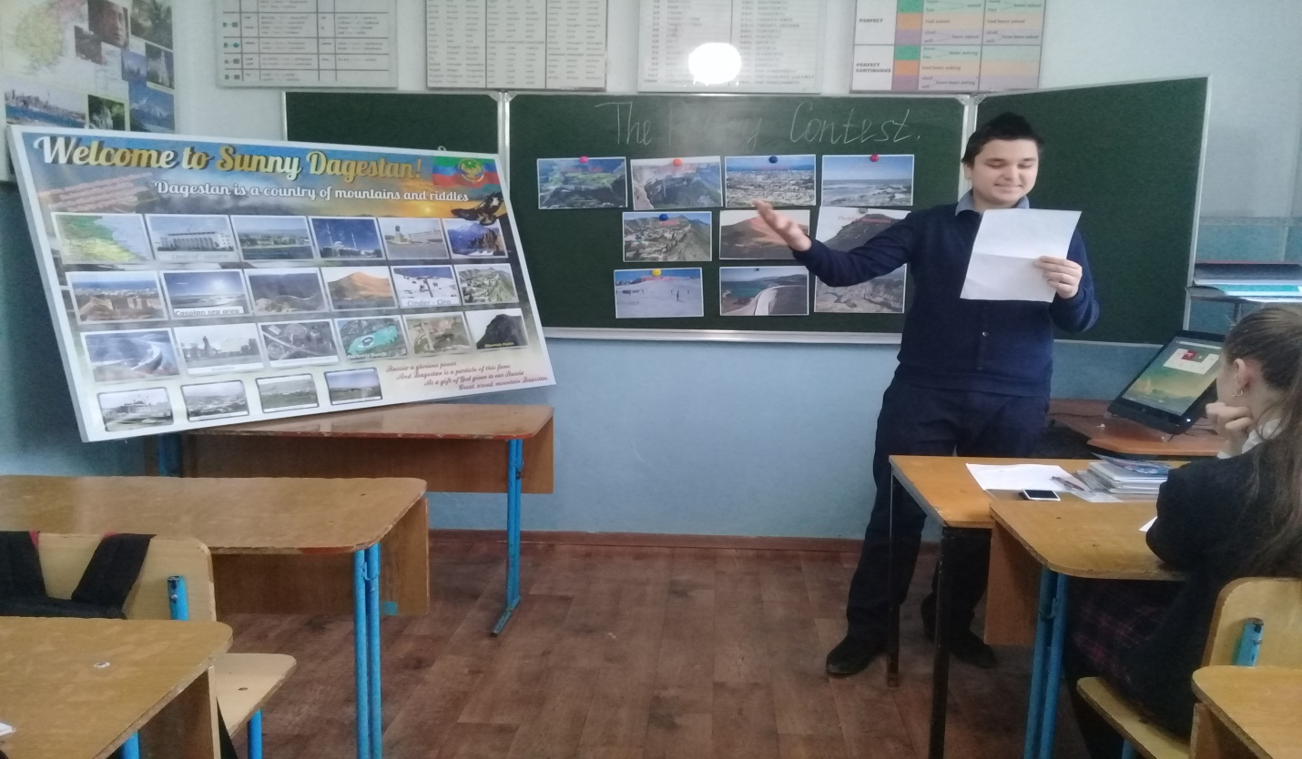
My native Dagestan!
My Dagestan is my light.
It’s loving place in my life.
Has green grass, its sky is white.
Water is blue and hills are bright.
The place where children can play.
Where sun is shining all the day.
We live in peace and holiday.
We’re not going to leave away.
I love my country very much.
Our people and nature and beasts.
For trees and leaves. I like to touch.
East or west home is the best.
Dagestan is a beautiful place.
Nights are dark and days are light.
Our mountains are touching the space.
Our people are honest and bright.
The Caspian Sea – is our pride.
Sunshine is like a kiss of a bride.
Forests and fields, gardens and hills.
Women and girls are like daffodils!
Atlanaul gymnasium- Mutalibov Magomed - 8th form

