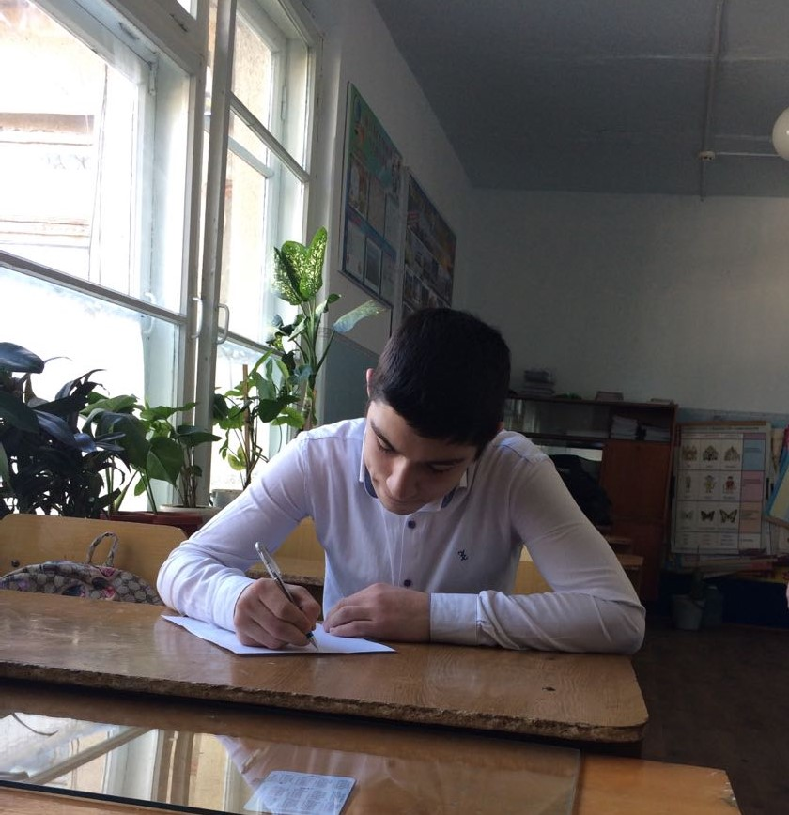
My native Dagestan!
What is Motherland? Maybe it is the place of my birth? Maybe it is the place of birth of my parents? Maybe – the place where are all your relatives and friends live? In addition to these questions I can add my opinion of it. Is for me-Motherland it is the place, which attracts you all the time. And you can not leave it. You want to come back here wherever you are. My native county is Dagestan. It is mountainous republic in the south of Republic Federation, which has been famous for the unity of all it is people. The beauty of my native country is described by many writers and poet from all around the world. Dagestan has magnificent landscapes: You can find a lot of stately mountains, touching the blue sky, fields full of green grass and beautiful flowers, gardens, hills, amazing waterfalls, raging rivers, crystal clear lakes and the Caspian Sea. The nature is wonderful here. Clean air, which everyone dreams about, and mountains and the forests in the background of the blue almost transparent sky, seem to be fabulous. There are a lot of lakes, where you can fish, go boating or just swim. There are a lot of mushrooms and berries in the forest. But the main value of Dagestan is not its nature. It is helpful people and exquisite culture, rich traditions. Our people appreciate human dignity. Hospitality of our people is well-known all around the world. Dagestan people always lived in peace harmony with each other in spite of more then 30 nationalities. My gentle, loved, dear, beautiful Dagestan! I really want your forests and mountains to be full of calmness, harmony, and peace. In present days. I hope my native country will blossom in the future. I am proud to be from this small, but wonderful republic!

Atlanaul gymnasium- Khalilov Omar - 10 th form

