"Виртуальное путешествие по Лондону" (6 класс)

Цель: Обобщение материала по теме «Лондон и его достопримечательности».
Задачи:
- Воспитательные:
- формировать у учащихся уважение и интерес к культуре и народу Великобритании;
- формировать потребность в практическом использовании английского языка в социально-культурной сфере;
- воспитывать культуру общения.
- Развивающие:
- развивать у учащихся интерес к изучению английского языка;
- углублять познавательные мотивы;
- развивать эмоциональную сферу учащихся и их актёрские способности.
- Образовательные:
- обобщить и расширить знания учащихся о столице Великобритании, обычаях и традициях страны;
- расширить общий и лингвистический кругозор учащихся.
- Практические:
- развивать у учащихся умения и навыки монологической и диалогической речи;
- учить учащихся применять Present Perfect с ранее усвоенной грамматической конструкцией Past Simple;
- развивать умение выступать публично с подготовленным устным сообщением на заданную тему.

Технические средства обучения: мультимедийный проектор ,презентация

I. Организационный момент.
Today our lesson will be unusual.
Have you ever been to London? I suppose you haven’t. Now you have such an opportunity.

At our lesson we’ll make a trip to London, the capital of Great Britain. It’s one of the oldest and most interesting cities in the world.

ll. Фонетическая зарядка.
Работа над произношением слов по изучаемой теме. Индивидуальное и хоровое повторение.
[æ] – travel, capital, gallery;
[ei] – play, place, stadium;
[ju:] - museum, new, beautiful;
[i]- big, pig, different;
[a:] – park, car, partner;
[i:] – see, meet, week
IIl. Повторение грамматики.
- But at first let’s revise Past Simple
What words do we often use in Past Simple? (yesterday/last/ago/in)

What form of the verb and what auxiliary (вспомогательный} verb do we use in Past Simple? (V2/did)

Let’s read some examples:
- And do you remember Irregular verbs? Let’s revise some of them (be/see/read/buy/meet/build)
- And now let’s make up the sentences.
- составьте предложения с этими глаголами
- Read ,please.
Very good. Thank you.

III. Речевая зарядка.
Игра с мячом. Учитель говорит утверждение и бросает мяч. Ученик ловит мяч, соглашается или не соглашается с утверждением.
- Red Square is in Moscow.
- Trafalgar Square is in London.
- Moscow is the capital of the UK.
- Moscow is different from London.
- London is the biggest city in the UK.
- You don’t want to visit Great Britain.
- There are a lot of places to visit in London.
- London is one of the most interesting and famous cities in Europe.
Повторение лексических единиц.
Before going to London let’s review all the words which will help us in our journey. I’ll name the letter and your task is to name the word which begins with this letter.
B: Bank of England, Buckingham Palace, Big Ben, British Museum, bury C: crown, church, Covent Garden, column, Changing the Guards F: financial, fashionable, fortress, famous H: Houses of Parliament, Horse Guards, Hyde Park, House of Lords, House of Commons N: National Gallery, narrow, Nelson’s Column, noble P: Palaces of Westminster, prison, Poet’s Corner, pavement T: Tower of London, Tower Bridge, Trafalgar Square, Thames
Excellent! Thank you.

- Драматизация диалогов.
And now let’s talk a bit. On your desks you have cards with the dialogues in Russian. Translate and dramatize them.
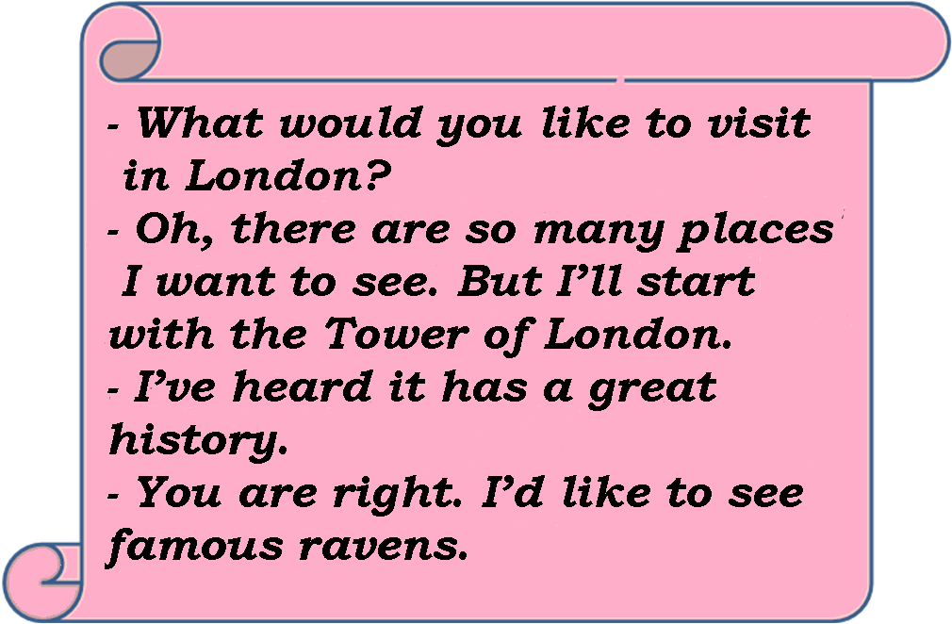
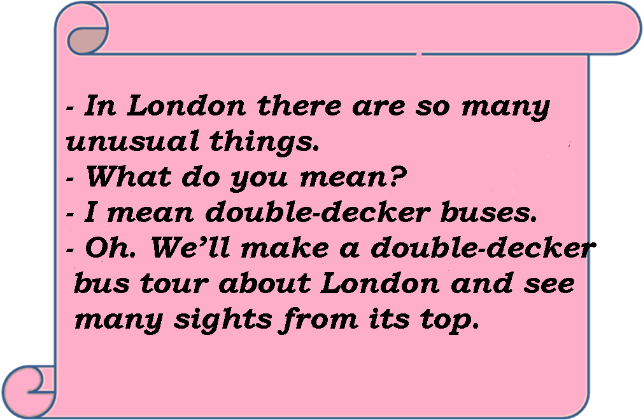

-

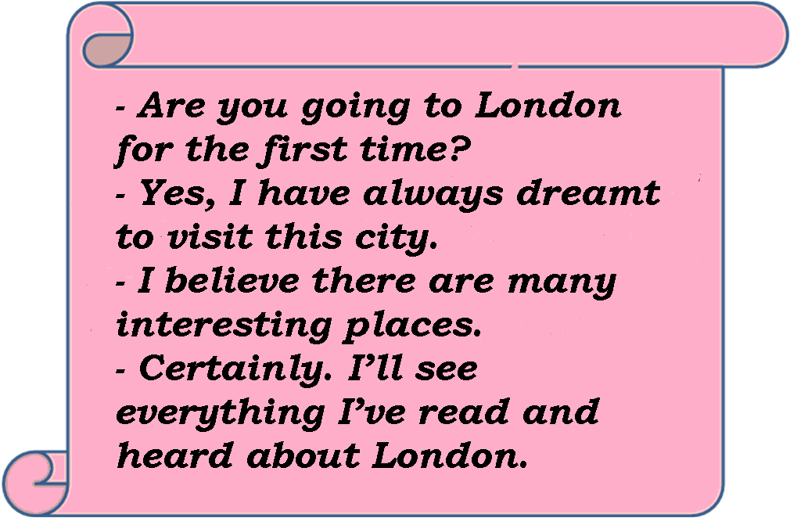

Perfect! Good.
IV. Основной этап.
- And now, ladies and gentlemen.
We welcome you to London.

LONDON - THE CAPITAL OF GREAT BRITAIN.
- And now, ladies and gentlemen.
We welcome you to London.
London is the capital of the United Kingdom of Great Britain and Nothen Irland. It Is political, cultural and baseness center. London is one of the largest cities in the world. About seven million people live here. London is more than two thousand years old. London consists of three parts: the City of London, the West End and the East End London’s most famous sights are Tower Bridge, Big Ben and the Houses of Parliament, Trafalgar Square and St. Paul’s Cathedral.
Your hometask was to prepare short reports about these sights. And start with the main square.
P1: Trafalgar Square is a geographical center of London. It’s the largest among London’s squares. On the column in the centre there is a statue of Admiral Nelson who defeated the French at the Battle of Trafalgar in 1805. The main building of Trafalgar Square is the National Gallery. It has a fine collection of European paintings. (слайды 20 - 21)

P2: Now we pass famous London parks. Entrance to the parks is free and you may walk on the grass, lie down to rest on it, if the weather is fine you may even ride horses. London Parks have cafes and art galleries. Hyde Park became the first public garden. It is known for its Speaker’s Corner, where everyone can stand up and say what he wants. (слайды 22 - 23)

P3: At last we are at Buckingham Palace. It is the London home of the Queen. When the flag is flying on the top she is at home. There is a wonderful daily ceremony, which takes place at 11.30. Usually Londoners and a great number of tourists watch Changing the Guards in front of the Palace. It’s a very beautiful parade

The Queen
I was born in Windsor on 21 April 1926. My full name is Elizabeth-Mary- Alexander Windsor. My pet name is Lilibet. I was educated at home, taught to read and write by her parents. I knew foreign languages. I was made my speech on the radio in 1940.I was learned to drive. I was married Prince Philip in 1947. My first son Prince Charles was born in 1948. I came to throne in 1952. I was crowned in Westminster Abbey on the 2nd of June in 1953.
Now I play an important role in the country. I travel a lot. I have got four children: Prince Charles, Princess Anne, Prince Andrew, and Prince Edward. I have five official residences in Britain; Buckingham Palace and Windsor among them.

P4: In front of you there are the Houses of Parliament and Big Ben. The Houses of Parliament is the seat of the British government. There are two chambers in British Parliament: the House of Lords and the House of Commons. St. Stephan’s Tower of the Houses of Parliament contains the famous Big Ben. It is one of the most famous clocks in the world.

P5: In a moment you will see Westminster Abbey. It is a royal church. The last monarch coroneted in the Abbey was present Queen Elisabeth the IInd. Many English kings and queens were buried there. Westminster Abbey is famous for its Poets’ Corner too. Many great writers are buried there: for example Charles Dickens and Rudyard Kipling.

P6: Now we are crossing Tower Bridge over the river Thames. From here you can see the Tower of London. English kings lived there many years ago. It was a fortress, a Royal palace and a prison, but now it’s a museum. The ravens are another famous sight. The legend says that without them the Tower will fall.

P7: We are now making our way to the second famous church, St. Paul’s Cathedral. It is the greatest work of the architect Sir Christopher Wren. Many important public figures are buried here.

P8: The last point of our excursion is Covent Garden. It’s the biggest cultural and shopping center in Britain. It was a big fruit and vegetable market. It is now a tourist shopping centre with cafes and restaurants.

P9: Double-decker- a bus with two passenger decks. They are a common sights in Britain. London has more than three thousands double-deckers. At many seaside resorts Double-decker with an open top desk are used in the summer season for tourists.

P10: A telephone box - Sir Giles Gilbert Scott designed a telephone box in the 1920s. In 1985 more of them were replaced with modern telephone boxes. People protested so much at the old ones were put back in London. Now you can see them.

- You have just visited some interesting places in London. Let’s see how well you know them. Look at the photos and name them.
What is it? (Показываю иллюстрации некоторых достопримечательностей Лондона)

OK. Your memory is good.

Now, check up what you have learnt about these sights, how attentive you are.
Fill in the crossword answering the questions.

V. Заключительный этап.
Our tour has finished. Thank you for your attention and activity.
I hope very much that you have enjoyed our tour of London.
I hope your dream will be true.
Thank you for the lesson, you were good today.
All of you will get excellent marks. Goodbye.

